NOTES TO EDITOR
About the One Billion Trees Fund
BENEFITS TO NZ
The One Billion Trees Programme is not just about planting trees. It is about investing in our regions and enabling them to create their own sustainable, bright future.
More specifically, trees offer a wide range of benefits to landowners, communities, catchments, regions and New Zealand, including helping to:
- Improve land productivity;
- Tackle environmental issues like erosion;
- Reduce the effects of climate change by absorbing CO2;
- Improve water quality;
- Develop Māori-owned land where there are barriers to privately funded tree planting;
- Provide important habitats for a range of native species;
- Enhance natural landscapes;
- Provide another source of income from timber, honey and carbon credits;
- Create jobs and careers for our people.
DIRECT LANDOWNER GRANTS
The new grants scheme provides simple and accessible direct grants towards the cost of planting and establishing trees and indigenous regeneration.
$118 million is available over three years with applications open year-round.
Applicants might be looking to plant for reduced erosion, improved water quality, regional development goals, enhanced biodiversity, development of Māori owned land and to diversify productive land uses.
The new grants scheme will help us to get 60 million new trees in the ground over the next three years (with a target of two-thirds of trees being natives).
The focus on incentivising land owners to plant indigenous trees will help to achieve more diverse benefits, particularly through the restoration of indigenous ecosystems and biodiversity.
There are targeted rates to encourage natives, re-generation, trees for erosion control, and other environmental benefits.

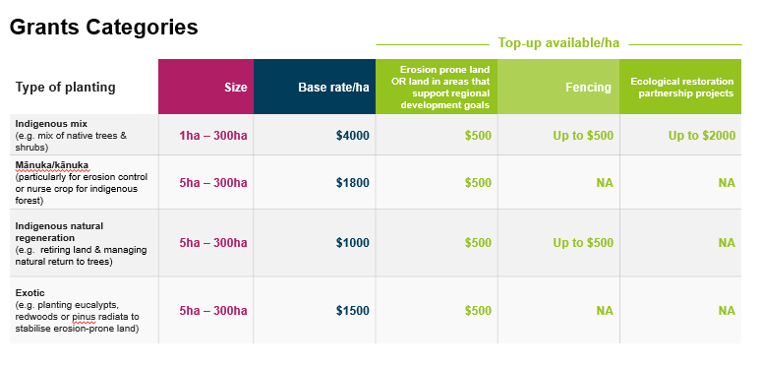
Grant categories include:
- Indigenous (e.g. a mix of native trees and shrubs).
- Mānuka / Kānuka (particularly for erosion control or as a nurse crop for an indigenous forest).
- Indigenous natural regeneration (retiring land and managing it to naturally return back to trees).
- Exotic (e.g. planting eucalypts, redwoods or pinus radiata to stabilise erosion-prone).
There are also top up grants for erosion prone land, planting that supports regional development, and fencing.
Tree planting grant recipients will also be able to register in the ETS, if eligible to do so (unless planting pinus radiata – this will be limited to after six years).
PARTNERSHIP GRANTS
$120 million is available over three years and will see a closer working relationship with a range of partners from regional councils to NGOs to researchers, training organisations, Māori landowners and community groups.
The partnership fund will support projects that reduce barriers to tree planting, and will leverage co-funding, along with existing know-how and experience, from partners and landowners.
It will contribute additional planting to the overall one billion trees target by investing in projects and initiatives that reduce the current barriers to tree planting.
We’ll look to promote innovation, secure sufficient labour to get trees in the ground, and provide support and advice to landowners on how they can improve land-use.
The Fund will align with the PGF criteria which includes:
- Increased sustainable regional development;
- Increased productivity and innovation in forestry and related sectors;
- Increased employment, training or work readiness;
- New Zealand’s ability to meet its climate change obligations;
- Māori aspirations for utilising their land and resources; and
- Enhanced environmental sustainability and/or productivity of natural assets.
Projects will like be supported that support:
- Labour and workforce development – enhanced availability of labour to establish, plant and maintain trees, and an upskilled workforce. This includes improving employment conditions, supporting more young people into forestry sector employment, and building a stronger skills pipeline for the industry.
- Advice and information for landowners – improved information, technical advice and extension services to support landowner decision-making, as well as communications to build understanding of and support for the multiple values of forests and different species options.
- Catchment-based or landscape scale tree planting and restoration projects – to deliver improved environmental outcomes in relation to erosion control, freshwater quality and biodiversity.
- Science and research – including modelling tools to support decision making around land use change and optimal land use, methodologies to increase seedling production and improve seedling quality, and research into overcoming social barriers to tree planting.
- Seedlings and nursery production – including creating more efficient production relative to demand and supporting initiatives that will deliver the diverse range of tree species required for the programme.
Partners will typically be required to co-fund at least 50% of commercial projects. The ratio of co-funding for commercial and non-commercial applications will be negotiable where applications demonstrate the ability to deliver strong social and environmental benefits that would not be achieved without a greater level of public investment.

FACTS & FIGURES FOR THE ONE BILLION TREES PROGRAMME - AS AT 30 NOVEMBER 2018

- $480 million is available for the One Billion Trees Programme, allocated from the Provincial Growth Fund. To date:

  - $25.8 million has been allocated for partnership projects through the PGF.
  - $50.8 million has been allocated for Crown Forestry Joint Ventures
  - $34 million has been set aside for the Hill Country Erosion Programme, to work with regional councils to deliver benefits to landowners.
  - $120 million is now available for partnership projects
  - $118 million is now available for direct grants to landowners planting trees.

- Approximately 60 million new trees have been planted in 2018 through a combination of direct government investment (Crown Forestry joint ventures and existing tree-planting grants 6.5m) and commercial forestry activity.

- The annual planting rate is expected to increase to 100m per year in 2020.

PARTNERSHIP PROJECTS TO DATE (through PGF applications)

Project Name | Overview | Cost | Region | Contract Length
Funding Agreements Signed
Te Uru Rākau Forestry Scholarships | Offer and fund eight Forestry Scholarships in 2019 at University of Canterbury | $ 1,139,000 | Nationwide | 6 years
Manuka Farming NZ Ltd | Plant and establish up to 1.8 million manuka seedlings to develop manuka plantations. | $ 1,716,050 | Nationwide | 1 year
Matariki Tu Rākau | Planting up to 350,000 native trees to commemorate members of New Zealand's Defence Force. | $ 5,544,000 | Nationwide | 3 years
Minginui Nursery | Increase production of forestry grade native seedlings to an industrial scale using specialist propogation techniques. 1.8m native seedlings plus social development outcomes including a number of extra FTEs. | $ 5,800,000 | Bay of Plenty | 3 years
Ngati Hine Manuka / Training Project | 400+ha of manuka and two year forestry training programme for 40 trainees. | $ 1,895,000 | Northland | 2 years
Horizons Regional Afforestation Initiative Stage 1 | Plant 1.355 million seedlings during winter 2018. | $ 970,600 | Manawatu-Whanganui | 1 year
Trees That Count | Expand TTC programme, recruit the equivalent of six FTE regional advisors, increase marketplace for corporate / private indigenous tree funders. | $ 6,650,000 | Nationwide | 3 years
ManaiaSAFE Forestry School Pilot | Pilot phase of the ManaiaSafe Forestry Schools with 11 trainees in a pseudo-commercial environment. | $ 301,000 | Gisborne | 1 year
Punakaiki Coastal Restoration Project (DoC) | Planting 350,000 native trees on the West Coast of the South Island. | $ 1,209,000 | West Coast | 3 years
Ngati Rēhia Kauri Sanctuary Feasibility | Feasibility study into a staged and long term partnership between Ngati Rehia, a research institution and the government, with nursery and a kauri plantation. | $ 288,000 | Northland | 1 year
Te Waihora Restoration (DoC) | Planting 200,000 trees over 100ha in the Canterbury area of the South Island. | $ 1,059,000 | Canterbury | 3 years
Scion Totara Industry Pilot | Investigate the potential for a commercial tōtara industry in Northland. | $ 450,000 | Northland | 1 year
TOTAL AMOUNT |  | $ 25,882,650

